Volume 1, Issue 2, December 2026 | Print ISSN 3156-7347 | Online ISSN 3156-7339 | DOI:
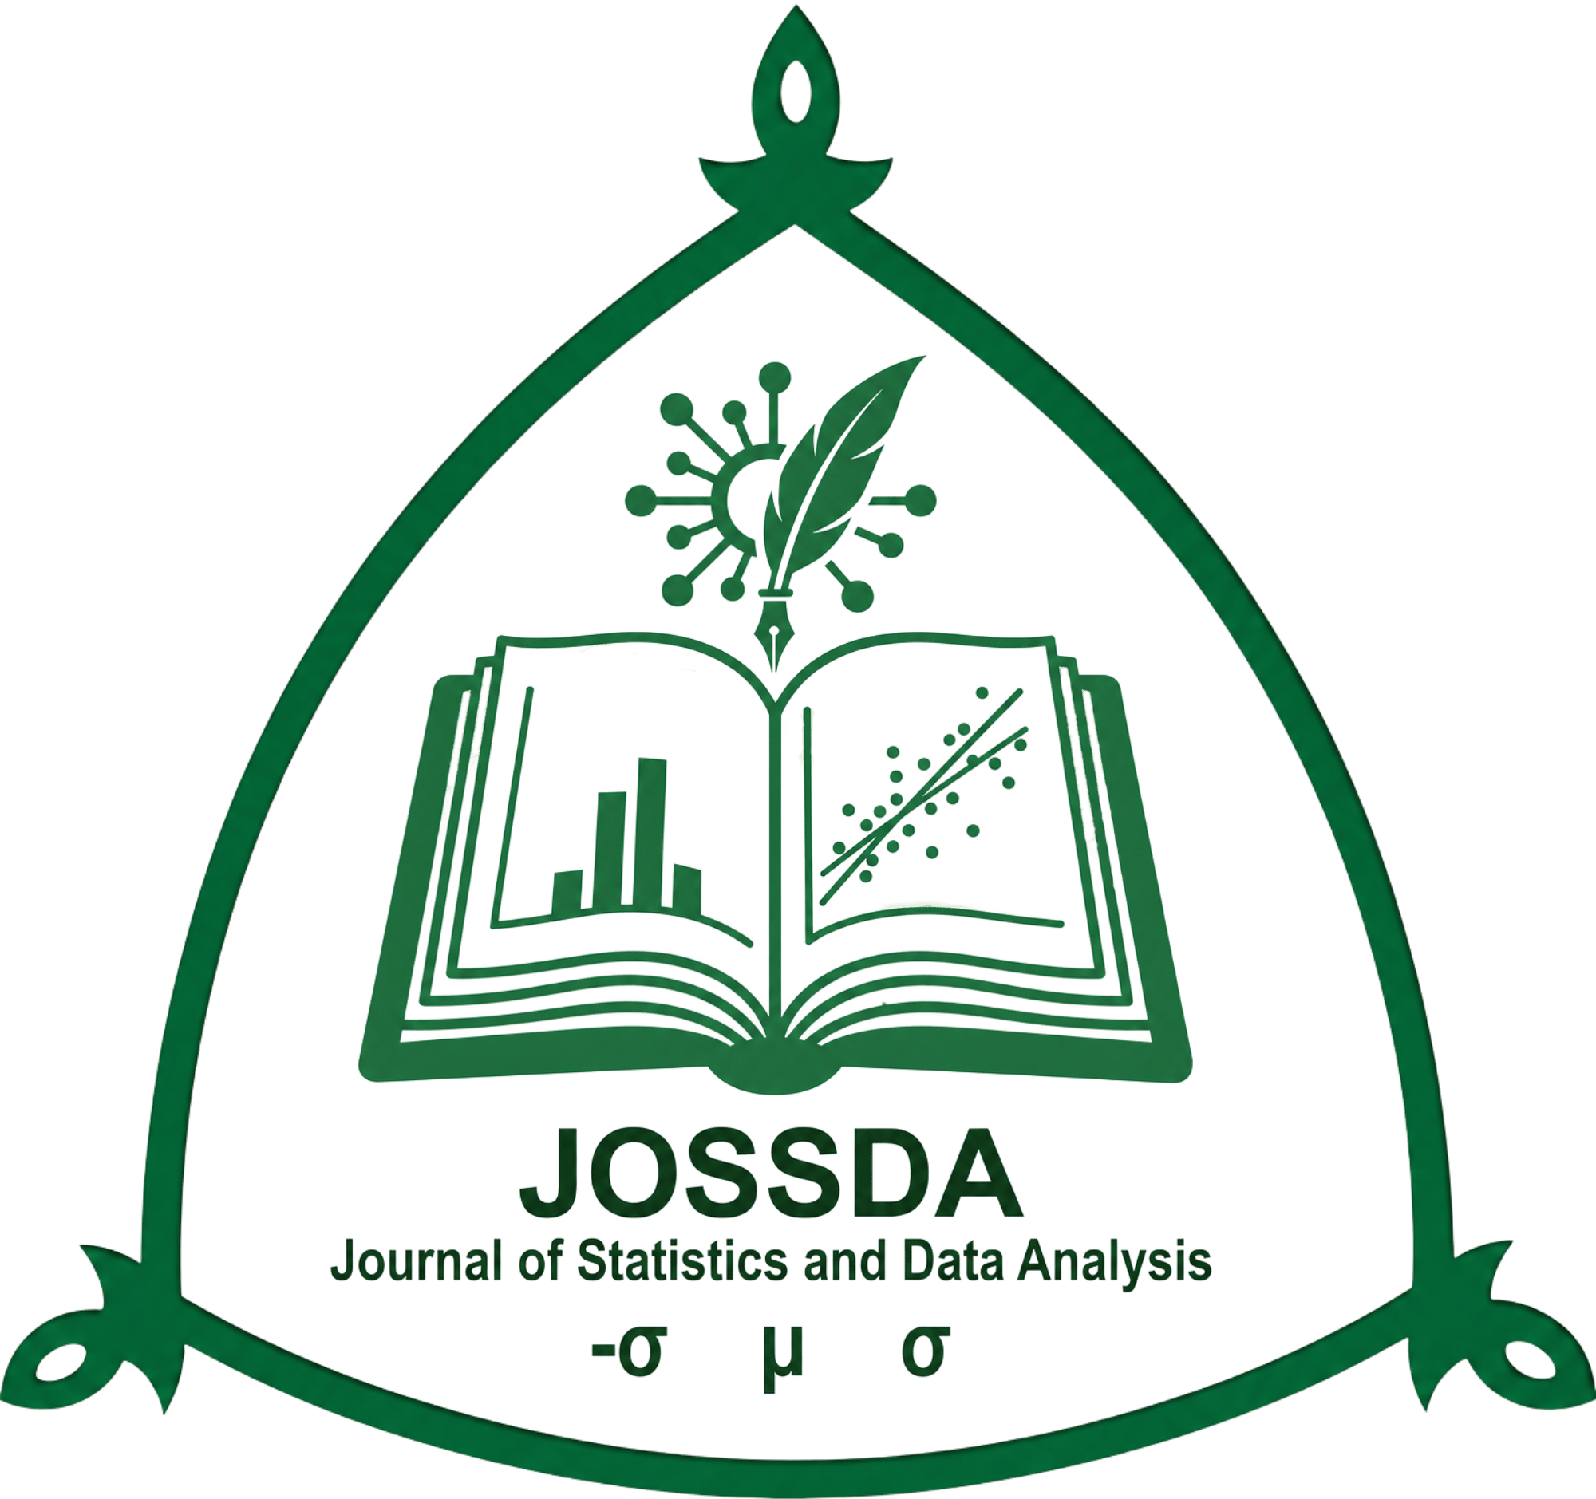
JOURNAL OF STATISTICAL SCIENCES & DATA ANALYTICS
Department of Statistics, Ahmadu Bello University, Zaria, Nigeria | jossda.com.ng
[Delete this note and every other bracketed note in this template before submission — manuscripts still carrying template guidance are returned for correction rather than moved into review. Format the manuscript in Times New Roman 12pt, single line spacing, 1-inch margins, and full justification, with page numbers bottom-centre, keeping the headings, styles, and numbering below unchanged. Replace the sample title, authors, and section text with your own manuscript content. Full submission requirements are set out in the JOSSDA Author Guidelines at jossda.com.ng/submit/guidelines.]
Digital Learning Engagement and Academic Performance: A Regression Analysis of Undergraduate Statistics Students
H. N. Balogun¹, S. M. Okonkwo², and R. A. Danjuma¹
¹Department of Statistics, Ahmadu Bello University, Zaria, Nigeria
²Department of Mathematical Sciences, Bayero University, Kano, Nigeria
Corresponding Author:
H. N. Balogun, Department of Statistics, Ahmadu Bello University, Zaria, Nigeria.
hn.balogun@abu.edu.ng | +234 803 000 0000 | ORCID: 0000-0000-0000-0000

Abstract
[150–250 words. State the purpose, methods, principal findings, and conclusion in a single justified paragraph, without citations.]
Digital learning platforms have become a routine part of undergraduate statistics instruction, yet evidence on how platform engagement relates to academic performance in Nigerian universities remains limited. This study examined the relationship between weekly digital learning engagement and end-of-semester examination scores among 405 undergraduate statistics students drawn from three faculties. Engagement was measured as the average weekly hours logged on the university's learning management system over a fourteen-week semester, and performance was measured using standardized examination scores. A multiple linear regression model was fitted with engagement hours, prior grade point average, and tutorial attendance as predictors. The results show a significant positive association between engagement hours and examination performance (β = 0.42, p < 0.001), after controlling for prior academic standing and attendance. Students in the highest engagement tercile scored, on average, 7.4 points higher than those in the lowest tercile. Prior grade point average remained the strongest single predictor, while tutorial attendance showed a moderate independent effect. These findings suggest that structured incentives for sustained platform engagement, rather than one-off usage, may meaningfully improve outcomes in large-enrolment statistics courses. Implications for course design and academic advising are discussed, along with limitations related to self-selection into engagement levels.

Keywords
[4–6 keywords, arranged alphabetically, separated by semicolons.]
Academic performance; digital learning engagement; higher education; learning management systems; regression analysis

1. Introduction
[Background and motivation, the specific gap in existing literature, and the study's objective and contribution.]
The shift toward blended and fully online delivery of quantitative courses has made learning management systems (LMS) a primary channel through which students access lecture materials, submit assignments, and engage in formative assessment. In statistics education specifically, where cumulative mastery of sequential topics is critical, the timing and consistency of engagement with course material may matter as much as raw contact hours in the classroom (Fullan, 2007).
Prior work on educational production functions has generally treated classroom-based inputs, such as student-teacher ratio and instructional expenditure, as the dominant predictors of academic outcomes (Darling-Hammond, 2000; Harris et al., 2010). Comparatively little attention has been paid to digital engagement metrics that are now routinely logged by institutional LMS platforms, despite their availability as a low-cost, continuously updated indicator of student effort.
This study addresses that gap by quantifying the relationship between weekly LMS engagement and examination performance among undergraduate statistics students, while controlling for prior academic standing and tutorial attendance. The specific objective is to estimate the marginal association between engagement hours and performance, and to assess whether this association holds after accounting for the confounding influence of prior ability.

2. Materials and Methods
[Describe data, variables, and the statistical, mathematical, or computational methods in enough detail for replication. Number equations sequentially, flush right.]
Data were drawn from LMS activity logs and examination records for 405 second-year undergraduate students enrolled in an introductory statistics course across three faculties during the 2025/2026 session. Weekly engagement hours were computed as the mean number of hours logged per week over the fourteen-week semester. Prior academic standing was measured using cumulative grade point average (CGPA) at the start of the semester, and tutorial attendance was recorded as the proportion of scheduled tutorial sessions attended.
The relationship between examination performance and the predictor variables was modelled using ordinary least squares multiple regression, specified as:
Yi = β0 + β1Ei + β2Ci + β3Ai + εi (1)
where Yi is the examination score for student i; Ei is average weekly engagement hours; Ci is prior CGPA; Ai is tutorial attendance proportion; β0 is the intercept; β1, β2, and β3 are regression coefficients; and εi is the error term. Statistical significance was assessed at the 0.05 level, and model diagnostics included tests for heteroscedasticity and multicollinearity (variance inflation factor < 5 for all predictors).

3. Results
[Present findings using numbered tables and figures. Table titles appear above the table; notes appear below. Figures are numbered and captioned below the image.]
Descriptive statistics for examination scores across the three engagement terciles are summarized in Table 1. Mean performance increased monotonically with engagement level, and the difference between the highest and lowest terciles was statistically significant (t(253) = 4.87, p < 0.001).
Table 1. Examination Performance by Weekly Engagement Tercile
Sample Size (n) | Mean Score | Std. Deviation | 95% CI
120 | 72.4 | 8.61 | 70.9 - 73.9
150 | 75.1 | 7.94 | 73.8 - 76.4
135 | 69.8 | 9.22 | 68.2 - 71.4
Note. CI = confidence interval for the mean. n = 405 across all terciles.
The fitted regression model explained 34.6% of the variance in examination scores (R² = 0.346, F(3, 401) = 70.72, p < 0.001). Weekly engagement hours were a significant positive predictor of performance (β = 0.42, p < 0.001), as was prior CGPA (β = 0.51, p < 0.001). Tutorial attendance showed a smaller but significant positive effect (β = 0.18, p = 0.004). Figure 1 illustrates the positive linear trend between engagement hours and examination score, with a 95% confidence band.
[Scatter plot with fitted regression line: Weekly Engagement Hours (x-axis) vs. Examination Score (y-axis), 300 dpi minimum]
Figure 1. Relationship between weekly LMS engagement hours and examination score, with 95% confidence band.

4. Discussion
[Interpret findings, compare with existing literature, and discuss practical or theoretical implications.]
The positive association between digital engagement and examination performance is consistent with the view that sustained, distributed contact with course material supports deeper processing of sequential statistical concepts, rather than performance being driven solely by classroom-based inputs (Darling-Hammond, 2000). That prior CGPA remained the strongest predictor suggests engagement complements, rather than substitutes for, existing academic preparedness. The moderate effect of tutorial attendance further indicates that in-person and digital modes of engagement may operate through partially distinct channels.
These results should be interpreted with caution given the observational design: students who engage more with the LMS may differ systematically from those who do not, in ways not fully captured by CGPA and attendance. Future work using randomized engagement incentives would help establish a causal interpretation.

5. Conclusion and Recommendations
[Concise summary, limitations, and future research directions.]
Weekly digital learning engagement is significantly and positively associated with examination performance among undergraduate statistics students, independent of prior academic standing and tutorial attendance. Course coordinators may consider structured engagement incentives, such as graded formative quizzes released on a weekly cadence, to encourage distributed rather than last-minute platform use. Future research should examine whether these associations replicate across cohorts and disciplines, and should employ experimental designs to isolate the causal contribution of engagement from self-selection effects.

Acknowledgements
[Optional. Acknowledge funders, data providers, or technical support.]
The authors thank the university's Directorate of ICT for providing anonymized learning management system activity logs used in this study.

Ethical Statement
[Required when the study involves human or animal subjects.]
This study used de-identified, aggregate institutional records and did not involve direct contact with human participants. Approval for secondary use of anonymized LMS and examination data was obtained from the host institution's research ethics committee.

Conflicts of Interest
[Mandatory statement, even if there is no conflict.]
The authors declare no conflicts of interest.

Funding Statement
[State funding source, or that no external funding was received.]
This research received no external funding from any public, commercial, or not-for-profit funding agency.

References
[APA 7th edition, arranged alphabetically by first author surname.]
Darling-Hammond, L. (2000). Teacher quality and student achievement: A review of state policy evidence. Education Policy Analysis Archives, 8(1). https://doi.org/10.14507/epaa.v8n1.2000
Fullan, M. (2007). The new meaning of educational change (4th ed.). Teachers College Press.
Harris, D. N., Ingle, W. K., & Rutledge, S. A. (2010). How teacher evaluation methods matter for accountability: A comparative analysis of teacher effectiveness ratings. American Educational Research Journal, 47(2), 349-376.
Owolabi, T., & Musa, A. (2022). Bayesian modelling of rainfall extremes. Journal of Climate Statistics, 14(2), 55-70.
World Bank. (2020). Nigeria data profile. https://data.worldbank.org/

